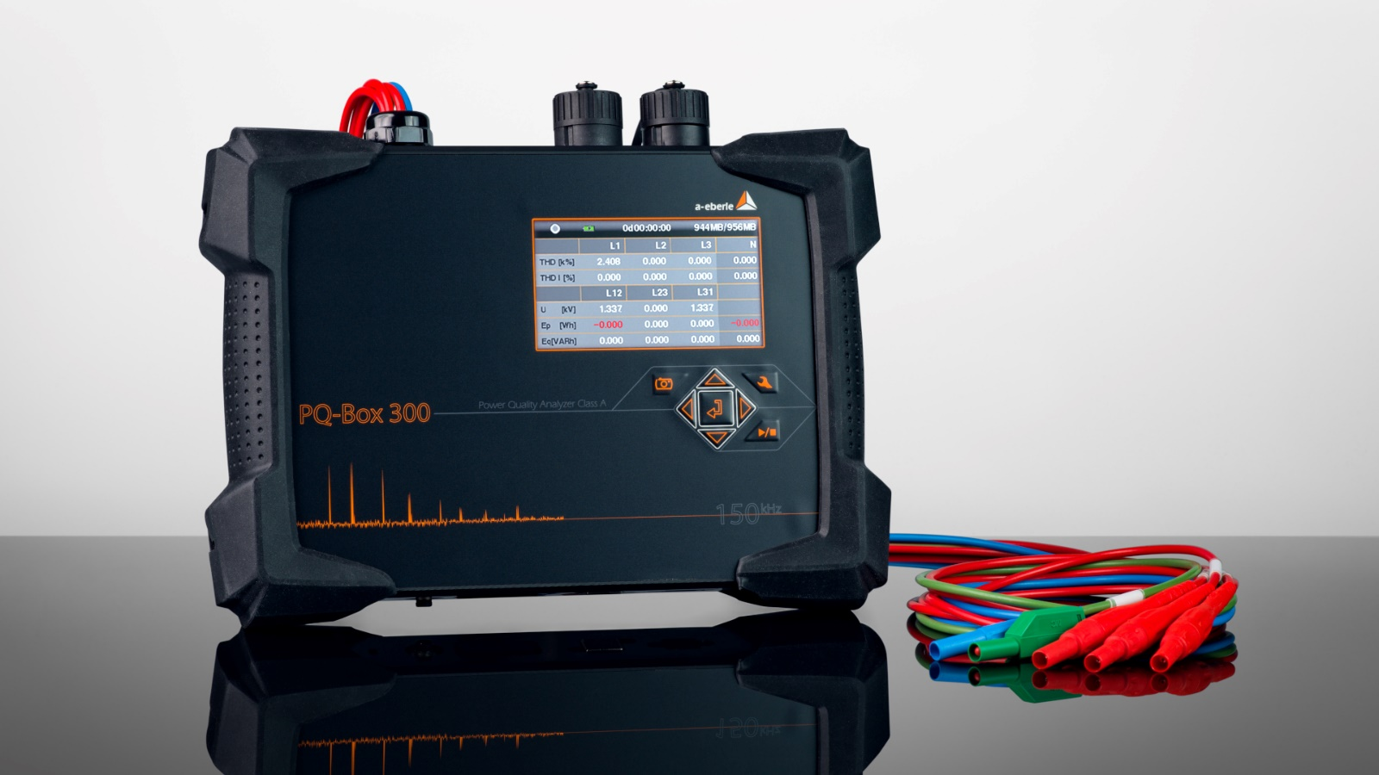

PQ-Box 300
Technical Specification
Mobile Power-Quality Analyser for Low, Medium and High Voltage networks

 | Tender Specification
Pos. 1:  General | - The mobile Power-Quality Analyser must be made for measuring 4 voltages and 5 currents in low voltage range and for measurements in medium and high voltage range via instrument transformers.  - The device must be compliant to IEC 61000-4-30 Ed.3 (2015) and fulfil the requirements for Class A. A confirmation of the measuring device standard according to IEC 61000-4-30 Class A by an independent test laboratory must be available.  - All fast recorder can be started via an external trigger input (AC/DC signals from 0 V to 250 V).  - For the measurement of 0 - 1000 mV signals, an AUX input is required. Units and scaling must be freely configurable. (E.g. simultaneous measurement of temperature and 4x voltage, 4x current)  - The accuracy limit of voltage- and current inputs must be < 0,1 %.  - Voltage and current inputs must be able to measure AC and DC values.  - Voltage range should be P-P: 0-830 V for AC and 1000 V for DC measurements, appropriate for measurements in LV systems and at instrument transformers in MV/HV systems.  - Measurement range current: up to 3000 A with flexible current clamps, optional up to 6000 A and mini current clamps for 1 A/5 A instrument transformers.  - The analyser must detect the connected clamps by coding and the settings must be set automatically.  - The voltage measuring channels must have a sampling rate higher than 400 kHz. Current measuring channels must have a sampling rate of 40 kHz.  - All input channels must have a resolution of 24 bit.  - The online measurement data (voltage, current, power, power consumption, THD, information about the number of PQ-events and fault records) can be viewed at a colour display.  - The analyser must be equipped with a memory of min. 8 GB. The memory card must be easily replaceable by the user. Memory cards up to 32 GB will be supported by the device.  - The device provides the following interfaces:  - TCP/IP  - USB  - WLAN and Wifi  - All interfaces provide full functionality  - The system must provide the monitoring of the threshold values of the following standards:  - EN 50160  - IEC 61000-2-2  - IEC61000-2-4 (class 1, 2, 3)  - NRS 048  - IEEE519  - DACHCZ  - VDE AR 4100  - The device must calculate the angle of current- and voltage-harmonics in relation to the fundamental voltage oscillation according to IEC 61000-3-12 standard (Reference the phase angle of each current harmonic is the fundamental of the voltage).  - The flicker measurement must be class F1 according to IEC 61000-4-15 standard.  - Settings like nominal voltage, transformer ratio, measurement range are able to be set via display control (no PC is required)  - The measuring interval must be freely programmable in range of 1 sec to 30 min.  - The following measuring intervals must be recordable without restriction to the number of values parallel in one measurement:  - 200 ms  - 3 sec  - 1 sec to 30 min (variable)  - 2 h.  - The evaluation of standards with 10 min data must be recordable up to 1 year without any loss of data.  - No pre-selection of measurement values has to be made. The device must be able to compute and record all 4000 parameters for voltage quality and load analyses simultaneously.  - The FFT calculation and visualisation of harmonics and interharmonics must provide the spectrum from DC to 170.000 Hz.  - The device must be able to calculate and permanently record voltages and current with frequencies of 2 kHz to 9 kHz as 200 Hz bands according to IEC 61000-4-7 standard. In addition, frequencies of 8 kHz to 170 kHz are measured. FFT calculation must be made as gapless 200 Hz sectors. The aggregation of the frequency sectors is adjustable to 200 Hz or 2 kHz.  - Long term data and all triggered events must be measured and recorded simultaneously as phase-to-ground and phase-to-phase values.  - Event type, measurement channel, duration and extreme values must be recorded for each type of event.  - Events are triggered by limit-value violations of EN 50160 standard or various trigger options.  - The trigger thresholds must be fully configurable by the user and independent of the EN 50160 or IEC 61000.x.x settings.  - For each trigger event, oscilloscope data and ½ Periode RMS data must be recorded.  - 3 year warranty for the analyser.  - The Dimensions of the device must not be greater than 200 x 180 x 40 mm.  - The device must function correctly in the temperature range -20 °C to +60 °C.
Pos. 2:  Functions | - The following measurement variables must be representable as continuous values:  - Effective values as minimal, mean and maximum value of 10 min interval  - Short- and long-time flicker  - Recorded trigger events must be represented as table or graphic  - Triggered events should be evaluable as effective value and/or as oscilloscope curve depending on previous parameterisations  - The following trigger types must be provided:  - Under- or overshoot of a predefined RMS value (voltage or current)  - Frequency trigger (frequency hopping, under- or overshoot)  - Envelope curve trigger  - Effective value hopping (voltage or current)  - Phase jump (°)  - Automatic trigger (trigger values are automatically adjusted by the device)  - Trigger events must be recorded as RMS and oscilloscope values. Duration and prehistory can be fully parameterised by the user.  - ½ period sampling – recording duration up to 600 sec.  - 40 kHz sampling – recording duration up to 4.000 msec.  - In case of supply disruption, an intern UPS (uninterruptable power supply) must supply the device for up to 3,5 hours.  - The possibility of an external time synchronisation via DCF77 and GPS-time clock is necessary.  - The display and all interfaces must be protectable against unauthorized access by a password.  - The device must provide theft protection via Kensington lock.
Pos. 3:  Software | - The software should be provided as a real 64-bit version.  - The evaluation software must be suitable for Windows 7, 8, 10 and 11 and enable graphical representation and prints of continuous measurement data and trigger events.  - In the graphic view, zoom and cursor functions must be available. Reports according to EN 50160, IEC 61000-2-2, IEC 61000-2-4, DACHCZ, VDE AR 4100 and NRS 048 should be generated automatically.  - Effective values, spectral display of harmonics, signal level diagrams and oscilloscope data may be analysed online.  - Harmonics and supraharmonics up to 170 kHz can be visualized in 3D-charts.  - Data export format should be:  - Comtrade  - CSV and XML  - A description in English must be attached to the hard- and software.  - The user interface of the analysing and operating software must be in English.  - The software and all updates have to be provided for free and without licenses or dongle.
Pos. 4:  App | For the network analyzer, an app for the iOS and Android operating systems must be supplied in parallel to the Windows software.  Online measurement data such as voltages, currents, power, energy consumption, THD, voltage and current harmonics as well as information about the number of PQ events and fault records can be displayed via the app.  Settings such as nominal voltage, converter factors, measuring interval can be changed directly via the app.
Pos. 5:  WinPQ Database | Data import into the existing PQ database from A. Eberle. All measurement data from the network analyzer must be able to be imported into the already existing PQ database for permanently installed PQ measuring devices from A. Eberle via an export interface.

