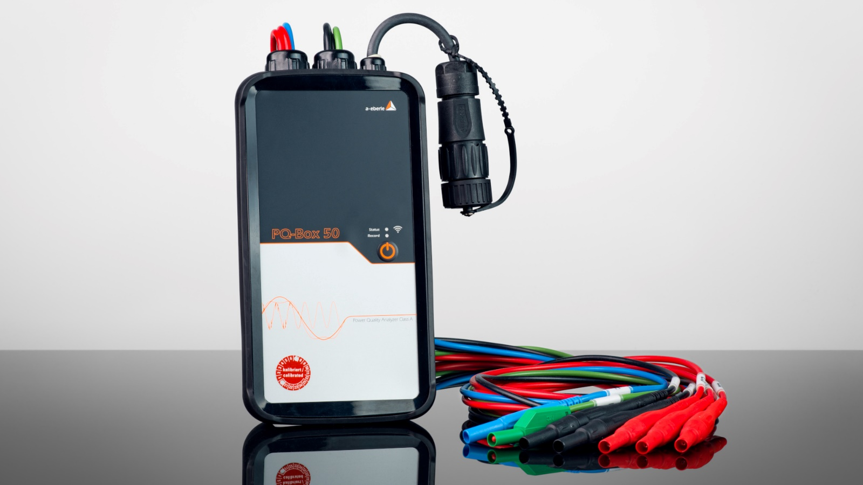

PQ-Box 50
Technical Specification
Mobile Power-Quality Analyser for Low, Medium and High Voltage networks

 | Tender Specification
Pos. 1:  General | - The mobile Power-Quality Analyser must be made for measuring 4 voltages and 4 currents in low voltage range and for measurements in medium and high voltage range via instrument transformers.  - The device must be compliant to IEC 61000-4-30 Ed.3 and fulfil the requirements for “Class A”. A confirmation of the measuring device standard according to IEC 61000-4-30 Class A by an independent test laboratory must be available.  - The accuracy limit of voltage- and current inputs must be < 0,1 %.  - The device must be very compact and must not exceed the following size: 220 x 110 x 40 mm.  - 3 year warranty for the analyser  - The device must function correctly in the temperature range -20 °C to +60 °C.  - The power supply of the device must be possible without an external power supply via the measuring lines.  - Voltage and current inputs must be able to measure AC and DC values.  - Voltage range should be P-P: 0-830V for AC and 1000V for DC measurements, appropriate for measurements in LV systems and at instrument transformers in MV/HV systems.  - Measurement range current: up to 3000 A with flexible current clamps, optional up to 6000 A and mini current clamps for 1 A/5 A instrument transformers. The analyser must detect the connected clamps by coding and the settings must be set automatically.  - The measuring channels must have a sampling rate of at least 20 kHz.  - The online measurement data (voltage, current, power, power consumption, THD, information about the number of PQ-events and fault records) can be viewed at a colour display.  - The analyser must be equipped with a memory of min. 1 GB.  - The system must provide the monitoring of the threshold values of the following standards:  - EN 50160  - IEC 61000-2-2  - IEC 61000-2-4 (Class 1, 2, 3)  - NRS 048  - IEEE 519  - DACHCZ  - VDE AR 4100  - The threshold values of EN 50160 and IEC must be fully configurable.  - The device must measure the angle of current- and voltage-harmonics according to IEC 61000-3-12 standard. Reference the phase angle of each current harmonic is the fundamental of the voltage  - The flicker measurement must be class F1 according to IEC61000-4-15 standard.  - Settings like nominal voltage, transformer ratio, measurement range are able to be set via display control (no pc required)  - The measuring interval must be freely programmable in range of 1 sec to 30 min.  - The following measuring intervals must be recordable without restriction to the number of values:  - 200 ms  - 3 sec  - 1 sec to 30 min (variable)  - 2 h  - The evaluation of standards with 10 min data must be recordable up to 1 year without any loss of data.  - No pre-selection of measurement values has to be made. The device must be able to compute and record all 3800 parameters for voltage quality and load analyses simultaneously  - The FFT calculation and visualisation of harmonics and interharmonics must provide the spectrum from DC to 10.000 Hz with a resolution of 5 Hz.  - Long term data and all triggered events must be measured and recorded simultaneously as phase-to-ground and phase-to-phase values.  - Event type, measurement channel, onset, duration and extreme values must be recorded for each type of event. Events are triggered by limit-value violations of EN 50160 or IEC standard or various trigger options.  - The trigger thresholds must be fully configurable by the user and independent of the EN 50160 or IEC settings.  - For each trigger event, oscilloscope data and ½ periode rms data must be recorded.
Pos. 2:  Functions | - Trigger events must be recorded as RMS and oscilloscope values. Duration and prehistory can be fully parameterised by the user.  - ½ period sampling – recording duration min. 600 sec.  - 20 kHz sampling – recording duration min. 4.000 msec.  - In case of supply disruption, an intern UPS (uninterruptable power supply) must supply the device for up to 4 hours.  - The possibility of an external time synchronisation via DCF77 and GPS time clock is necessary  - A description in English must be attached to the hard- and software.
Pos. 3:  Software | - The evaluation software must be suitable for Windows 7, 8, 10 & 11 and enable graphical representation and prints of continuous measurement data and trigger events.  - The software should be provided as 64-bit version.  - The following measurement variables must be representable as continuous values:  - Effective values as minimal, mean and maximum value of 10 min interval  - Short- and long-time flicker  - Recorded trigger events must be represented as table or graphic  - Triggered events should be evaluable as effective value and/or as oscilloscope curve depending on previous parameterisations.  - In the graphic view, zoom and cursor functions must be available. Reports according to EN 50160; IEC 61000-2-2, IEC 61000-2-4 and NRS 048 should be generated automatically.  - Effective values, spectral display of harmonics, signal level diagrams and oscilloscope data may be analysed online.  - Data export format should be Comtrade; CSV and XML.  - The user interface of the analysing and operating software must be in English.  - The software and all updates have to be provided for free and without licenses or dongle.
Pos. 4:  App | For the network analyzer, an app for the IOS and Android operating systems must be supplied in parallel to the Windows software. Online measurement data such as voltages, currents, power, energy consumption, THD, voltage and current harmonics as well as information about the number of PQ events and fault records can be displayed via the app.  Settings such as nominal voltage, converter factors, measuring interval can be changed directly via the app.
Pos. 5:  WinPQ Database | Data import into the existing PQ database from A. Eberle. All measurement data from the network analyzer must be able to be imported into the already existing PQ database for permanently installed PQ measuring devices from A. Eberle via an export interface.

