**A-Eberle_UM-Banner_Spannungsregler**

**Changes / new features WinREG 4.2**

from

WinREG V 4.1.2 of 15.08.2017

to

WinREG V 4.2.11 of 03.12.2021

Product name / type: WinREG parameterization software

**Date of creation:**

06.12.2021

**Creator:**Christian Schobert

**History:**

06.12.2021 Creation for 4.2.10

**Operating systems, system requirements:**

Windows 7, Windows 8, Windows 10

Windows Server 2003 or newer

Microsoft DotNet Framework Version ≥ 3.5

**Compatibility firmware**

The WinREG parametrization software is in general compatible with all firmware versions. That means you may

use the latest WinREG version also for old firmware versions. The WinREG 4.2 is optimized for REG-D(A) and

PAN-D firmware version 2.30/3.30 and REG-DP(A) firmware version 2.6.11.

The WinREG 4.2. is equipped with a version matrix. That enables the WinREG software to determine whether a

parameter is available in a certain firmware version or not. This function is available for REG-D(A) and PAN-D at

the moment. With this feature reading or sending features that have not been implemented yet in older

firmware versions is suppressed. However, the parameters will be correctly indicated in REGPara.

|  |  |
| --- | --- |
| C:\Users\korndhar\AppData\Local\Microsoft\Windows\Temporary Internet Files\Content.IE5\Z3PPV7G1\MC900344209[1].wmf | The WinREG software supports the Petersen coil regulator REG-DP and REG-DPA only to a limited extent. I.e. only basic parameters (e.g. without current injection) are provided. For complete parameterisation of the Petersen coil regulators, please use the A.Eberle Toolbox™ software. This is also available on the data media supplied or on the A. Eberle website. |

**New features**

**General:**

+ French language

The WinREG has been extended by the French language. The selection of the language is still done in the menu Options\Language or with the F9 key.

+ Adjustment of permissions and storage locations

With some versions of Windows 10 (e.g. Enterprise Edition), problems can occur with connection management and saving the contents of the terminal window. This has been counteracted by adjusting the permissions of the software (done during installation).

Furthermore, the storage location for the ini-file of the terminal and for saving the connections has been adjusted.

+ Basic setting for the communication timeout increased to 10s.

+ Bug fixing: When opening a desktop file, the connections for the terminal were not found. Now ok.

+ In rare cases, it can happen that the user directory of the WinREG is reported as not existing by the operating system. For this case, the directory is now always created. If the directory already exists, the creation is skipped without error message or abort.

+ For A. Eberle units with built-in USB, "a-eberle" is now also allowed in addition to the identification string "a.eberle". This string is already set during production and cannot be changed.

**REGPara:**

+ Extended setpoint settings

An additional window "Adv. Settings" has been added to the basic values for the additional settings of the setpoints.

+ Troubleshooting Nominal Power with parallel program dIsin(Phi)[S]

The parameter nominal power was not sent to the controller. Now ok.

+ Troubleshooting Number of LEDs of REG-DA

With the REG-DA, only the LEDs 1..7 (as with the REG-D) were displayed. However, the assignment of all 12 LEDs was saved correctly in the parameter file. The display is now ok.

+ UDM User variables added

In the WinREG, user variables from the UDM (User Defined Menu, extended background program for devices with feature S2) can now be used in addition to the user variables of the background program. This makes it possible to set an almost unlimited number of customized parameters. The parameters themselves as well as their value range etc. are defined in the UDM. WinREG reads them out and saves them. The corresponding value of the parameter can be changed and sent back to the unit. Some preliminary versions of the WinREG has had an issue with the input of decimal numbers when using certain regional settings (e.g. Lithuanian) on windows. This is fixed in WinREG 4.2.11.

+ Dialogue for differences in software features

When sending parameters, WinREG now indicates possible differences in the software features. For this purpose, a new dialogue was built which displays the active features in the parameter set and in the target device next to each other.

+ For the user variables of the background program, only the values (variable urat) are now transmitted to the device. Previously, the description, the min. and max. values as well as the unit were also written back to the unit.

+ The number of decimal places in the WinREG has been extended up to seven decimal places. This affects the following parameters in REG-D(A):

Bandwidth, Undervoltage, Overvoltage, Inhibit high, High Speed Switching Bwd and Fwd, Inhibit low, the Setpoints incl. Lower limit, Upper Limit, Base setpoint, 100% value, Gradient(I), Limitation (I), Undercurrent and Overcurrent, LDC parameters, Actual value correction and the Ratio of the VTs and CTs.

For the PAN-D, the following parameters are affected:

Inhibit high, <U1, >U2, <<U3, >>U4 and the Actual value correction.

+ Files with the line ending LF instead of CRLF are now also supported when sending background programs and udm-files.

+ Extended functions and update of parameters for the latest REGSys™ firmware versions 2.30 and 3.30.

REG-D(A)

* System Additional serial interface COM 5.

Features extended by the feature Sysctrl3

* Basic values Advanced settings for setpoints

- Number of setpoints

- Basic setpoint

- Setpoint lower limit

- Setpoint upper limit

- Base activation

* Current influence The value range of R and X in the LDC program has been extended to ± 100 Ω.
* Parallel operation The value range of the parameter "Maximum step difference" has been extended

from 6 to 128.

* Analogue I/O The differentiation between Big and Little Endian when using virtual analogue

analogue channels with MODBUS has been dropped. Now the address range for the data is 0...65535.

* REG-L UDM User variables (see above)
* Logbook mask Extension of the logbook masks (parameter changes, events TM, new system events)
* Expert param. Extension of the measuring channel assignment to eight channels (Phi2 and f2 are new)

PAN-D

* Functions Inverse tap changer with relay exchange
* Observation of the extended range for Inhibit high with the corresponding hardware.

+ The conversion of the analogue channel scaling from factor and offset to point input (POP2) was revised, as there was a calculation error there.

+ Error correction when reading out the background program of the REG-DP.

The background program was read out and saved, but not displayed directly after reading out.

+ Bug fixing for the number of binary inputs of the REG-D™.

For firmware versions 1.99 to 2.10, a number of 16 instead of 32 binary inputs was applied.

+ The description strings for the Master-Follower operation have been extended to the effect that they may be empty. Previously, WinREG did not accept empty strings.

+ Troubleshooting for the "Language" parameter

When reading out from the unit, German was also displayed for the language setting German. For all other languages, however, English was displayed. Now the language actually set on the unit is displayed.

+ Troubleshooting for the EventApps

Reading out the EventApps did not work correctly. The value -1 (inactive) was always displayed. Now ok.

+ Troubleshooting in the comparison dialogue

In the comparison dialogue when sending parameters, the values R and X for the LDC procedure were displayed interchanged. I.e. the labelling of the two parameters was mixed up. Now ok.

+ Troubleshooting when sending parameters of the REG-DP(A)

When sending parameters of the REG-DP, a runtime error 13 may occur. Now ok.

+ Service information area (ReadOnly) of the parameter file extended by some RBAC (Role Based Access Control) parameters.

+ Inclusion of the parameters Daylight Saving Time Rules, Characteristics and Eventapp in the CSV export. Correction of the output to the CSV. Up to now, the parameters converted for the display and not the real parameters of the unit were output there.

+ Error correction in the global MODBUS parameters for the MODBUS function for the analogue channels with regard to the readout of baud rate and parity.

+ MODBUS parameters included in the printout

+ Correction at CSV import regarding the analogue channels

+ Before sending the settings for COM2, the feature COM2Fix is now checked. If it is set, the settings are not sent.

+ Extension of the address range for the MODBUS function of the analogue channels to 0..65535. Switching between Little and Big Endian via the address is no longer necessary.

+ Baud rate 76800 removed for REG-D(A) and PAN-D.

+ If the WinREG 4.1 is used on an English Windows the parameter “Block high speed switching” was not correctly shown. The parameter is read and saved correctly but the indication in the REGPara is wrong if the parameter is active. Now it’s ok.

+ The WinREG 4.1 is not able to transfer the BAFUs (binary output functions) correctly to devices with the according legacy firmware version (e.g. 2.07). Now it’s working.

+ The software feature sysctrl exists since the firmware version 1.91. In the WinREG version matrix it was mentioned with firmware 2.00. That means that on some legacy firmware verions (e.g. 1.99) the feature cannot be set via WinREG. Now ok.

**Service:**

+ The menu item "User Management (COM)" now contains a note that COM2 must be excluded from password protection when using a scada interface card!

+ In the item Background program, REG-L and UDM files can now also be opened and sent when it contains LF instead of CRLF as the line end.

+ New texts have been added to the REG-DP logbook.

**Panel:**

+ View of analogue channels now switchable between mA and scaled measured value.

In the extended view of the panel with additional inputs and outputs, it is now possible to select whether the scaled measured value or directly the mA signal is to be displayed when viewing the analogue channels.

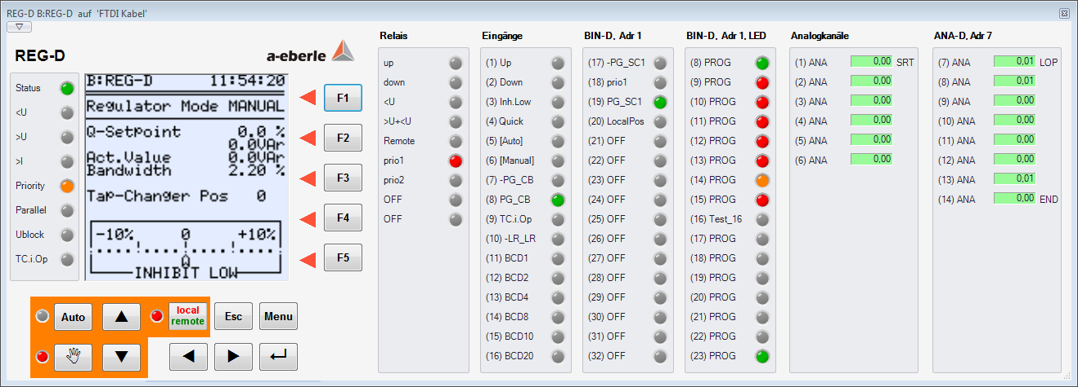

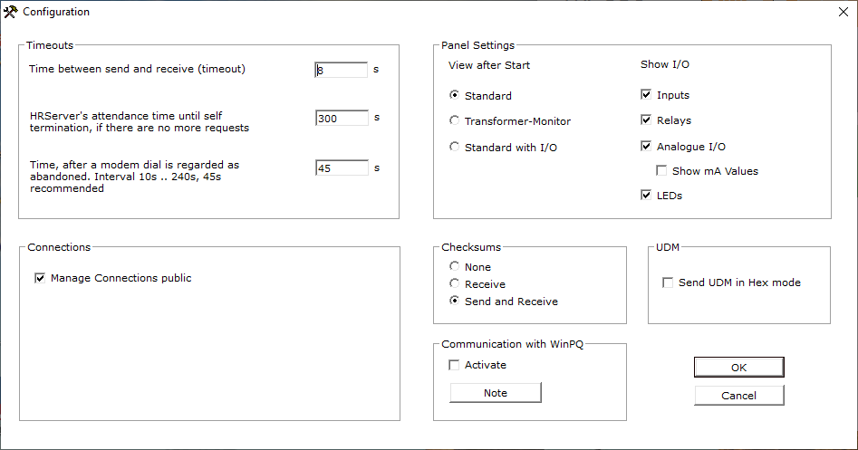

+ Panel view for PQI-D(A) units in UU (8xU) version

The panel view for PQ units (PQI-D and PQI-DA) has been extended for units with eight voltage measurement inputs (UU).

+ Error correction for the PAN-D panel

The display view of the PAN-D panel was not available. Now ok again.

+ PAN-D view with inputs/outputs

The panel of the PAN-D now also offers the possibility to display inputs and outputs.

+ Correction of a display problem with the PAN-D when the display with inputs/outputs is activated and only the inputs are displayed. In this case, the display of the binary inputs was slipped into the wrong area.

**Known issues and limitations**

+ No errors and comments